Game_Manager
The Game_Manager script is essential for this project. As the name suggests this script manages all aspects of the game. It is what uses most all of the assets/scenes/sprites/databases/scripts.

The following screenshots show case vital functions that are contained within Game_Manager along with descriptions of what the code accomplishes.
Instances of “GM” in descriptions take the place of “Game_Manager”
Instances of “SH” in descriptions take the place of “Signal_Hub”

_ready: This function of GM is called automatically by Godot when the game is launched. This function connects various other functions to signals emitted by SH. This tells GM to listen to signals and to run the function connected to that signal. This function also instantiates the current starting scene for the game.
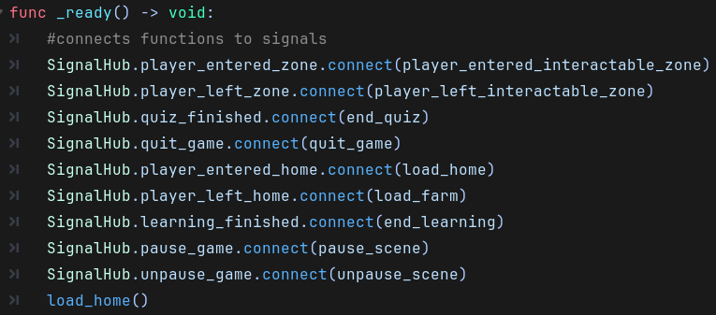
load_farm(), load_home(): These functions are responsible for freeing scenes that are currently displayed to the player. These functions also instantiate their related scenes and displays to the player. The load_farm() func calls another function called set_tree_data() this is used to give the 3 Tree scenes on the farm their associated data in order to display proper growth. Note the call_deferred function defers the execution of the code until Godot finishes processing all physics-based interaction. (I.E. area2D, staticbody2D, or collisionArea2D.)
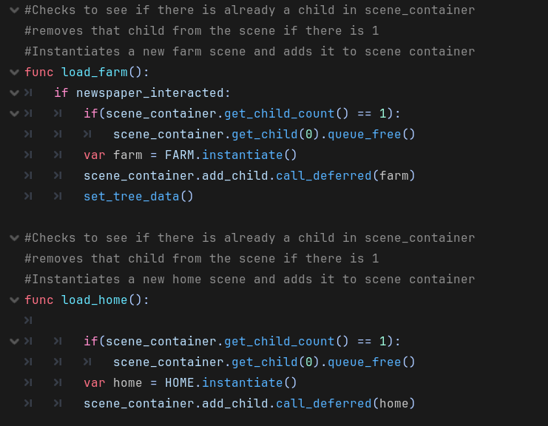

handle_interact: This function is called when the player presses the interact key, when inside the zone of an object. When the player walks into the interaction_zone of an object that information is stored in GM and is used to determine what code needs to be executed. This function uses flags to stop repeated interaction with objects that should only be interacted with once a day or when other objects are interacted with. This function calls the pause_scene function that pauses the current scene to stop input from the player to control the character or interact with an object. The last_quiz_tree variable stores the last tree the player interacted with and Is used to assign correct answers to the correct tree’s data set held by GM
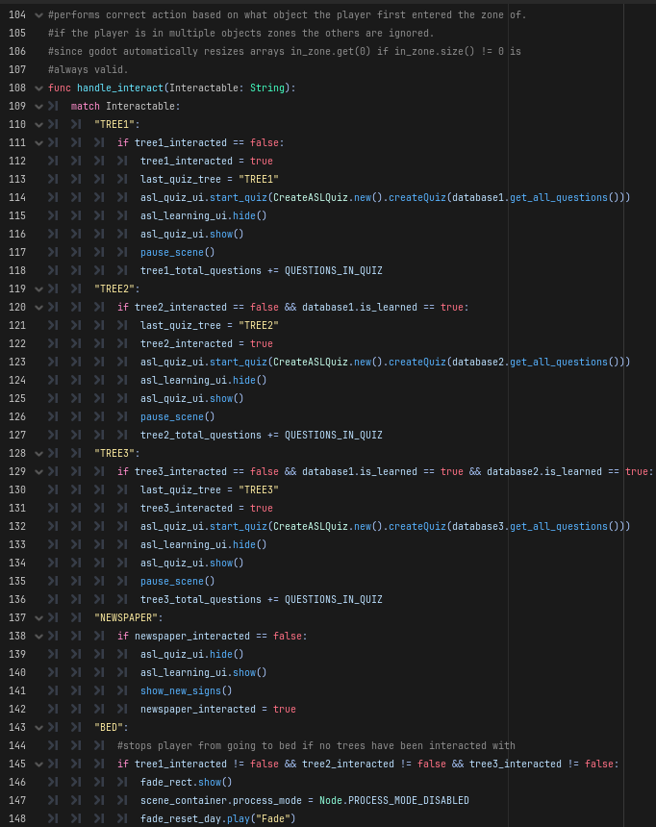
show_new_signs(): This function is called by handle_interact when the player is interacting with the newspaper in the home scene. This function uses asl_learning_ui and other ASL Learning classes to pick up to 4 ASL Signs not currently unlocked by the player, display, and unlock them. This function uses a Boolean variable called one_db_used. This is used to prevent data bases from mixing and unlocking signs from different data bases in one learning.
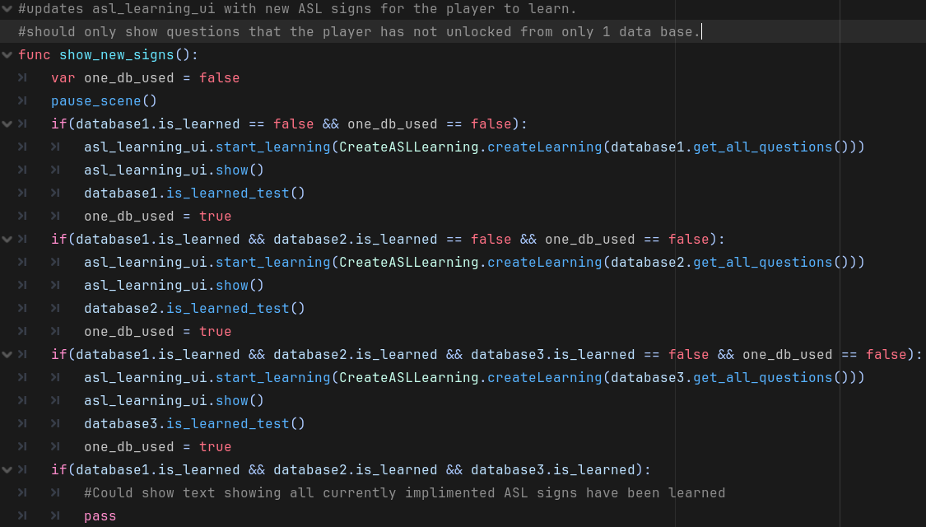

end_quiz(), end_learning(): These to functions handle when either a quiz has ended or the player feels they have learned the 4 new ASL Signs and is ready to move on. The questions answered correctly by the player are added to the correct variable based on the last tree the player interacted with.
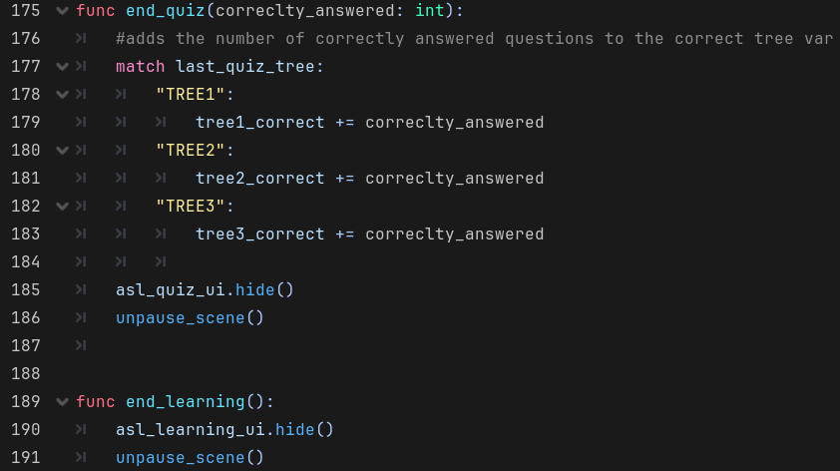
set_tree_data(): Stores the current tree information into tree_data and emits that data via signal, using signal hub. This is used by Tree scenes to correctly assign growth levels each time the farm scene is instantiated.
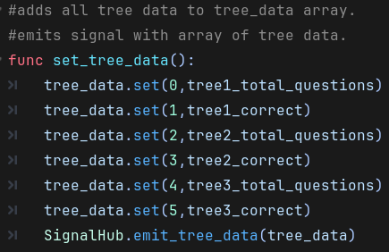

quit_game(), player_entered_interactable_zone(),
player_left_interactable_zone(): The quit game function is used when the quit_game signal is emited. The other 2 functions are used to store what object the player is currently in the interaction zone of. If a player enters an interaction zone of an object the object is added to the in_zone array of Strings. If the player leaves an interaction zone of an object the object is removed from the in_zone array of strings. These functions use the signals player_entered_interactable_zone and player_left_interactable_zone. These signals are emitted by the corresponding emit function in SH when called by either a Tree, Newspaper, or Bed scene.
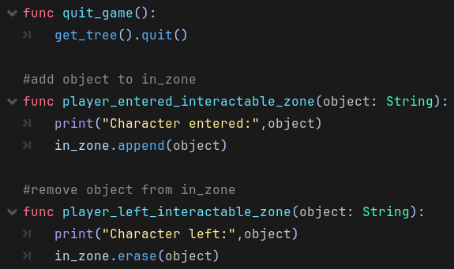

_on_fade_reset_day_animation_finished(): This function is connected to a signal not emmited by signal hub, but instead emitted by an animation player when the animation has finished player. This particular animation is used when the player interacts with the bed. When this happens the screen fades to black, then fades back in to reset the day. All flags that indicate an object has been interacted with resets to false and the unpause_scene is called to allow the player to move and interact with the character again.
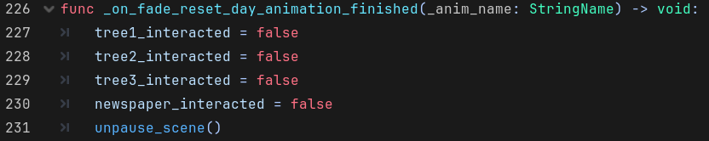

Signal_Hub
This script is used to consolidate signals used by multiple scripts. These types of signals are declared in this script and a corresponding function is added that emits the signal.
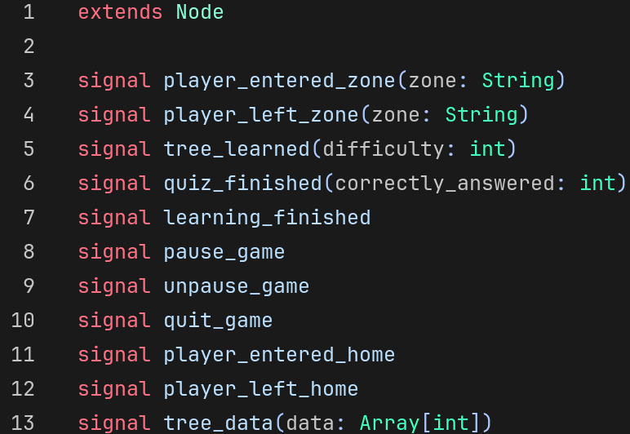
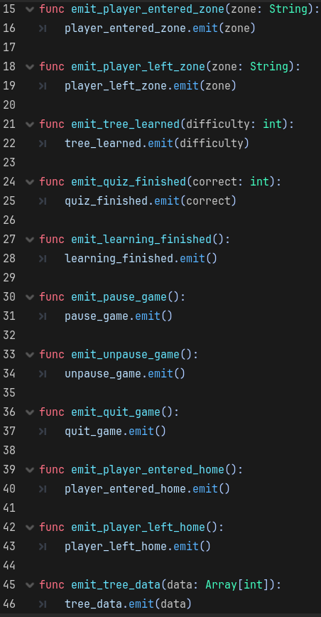

Tree
This script is attached to the Tree scene. The script is used to display one of 3 sprites of one of 3 different tree types and show progress based on the amount of questions answered correctly and total questions unlocked.
Variables: obj_name is exported, which means it can be assigned a name when instantiated into a scene. Each tree stores 3 sets of sprites d1,d2, and d3. Each sprite set has 3 levels of growth t1,t2,t3. The variables here are references to those sprites. The growth_stage variable is used to display what tier (t1,t2,or t3) to display based on progress. The total_questions and answered_correctly varaiables are used to increment growth_stage based on % correct.
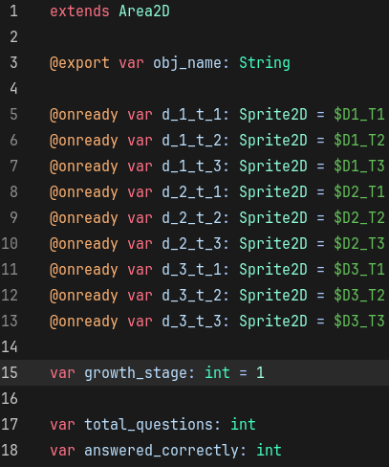

_ready(): This functions connects the tree_data signal to set_tree_data and calls show_growth. This function is called automatically by Godot when instantiated.
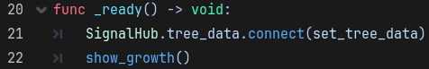
set_tree_data(): Is called when the tree_data signal is emitted by Signal_hub. This function pulls information from the tree_data array and stores the information based on the name of the object into total_questions and answered_correctly. This function then calls the grow() function to ensure the growth_level is adjusted.
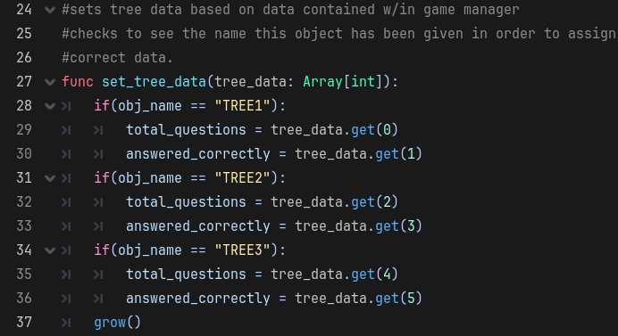

grow(): Is used to set the growth_stage of the tree or regress the growth_stage if the player is not performing well. This function then calls show_growth to display the correct sprites.
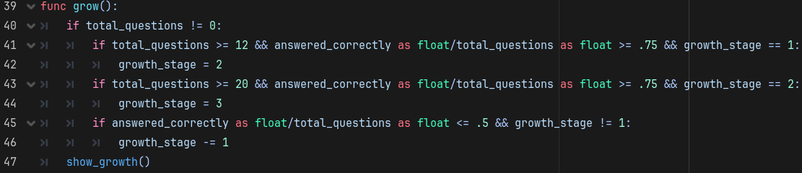
Show_growth(): Is used to display the correct sprites. It checks the growth stage, compares the name of the object to determine what sprite it should show, then dsiplays the correct sprite.
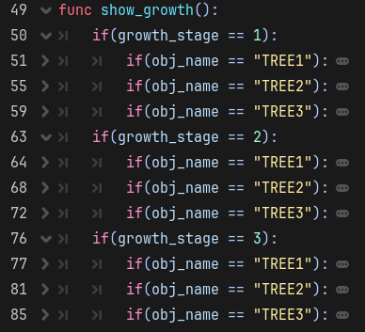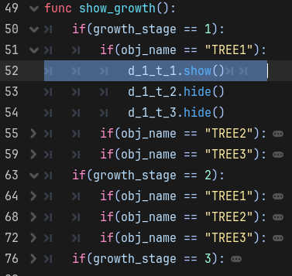

_on_body_entered(),_on_body_exited(): These functions are used to detect when the character enters/leaves the interaction zone of the tree. The functions then emits an enter/leaves signal using SignalHub and sends the object name with it.
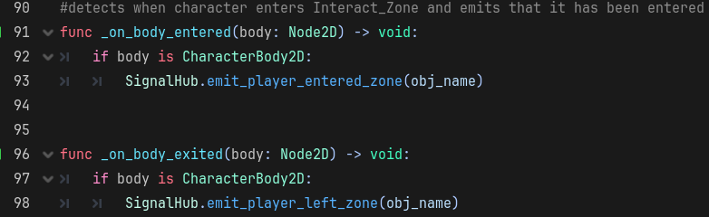

Character
The character is the medium to how the player interacts with the game. The player can move the character around the map and is able to interact with objects to learn ASL Signs and test their knowledge via ASL Quizzes.
Variables: The walk variables are references to animated sprites that are used when the character is moving. MOVE_SPEED is used to determine how fast the character is able to move. The move_direction Vector2 variable is used to determine what direction the player is moving.
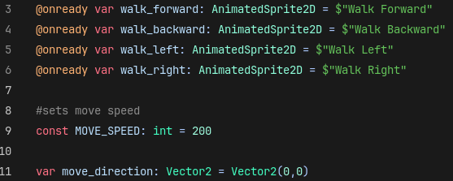
play_animation(): plays the correct animation based on the direction the player is moving and stops all other animations.
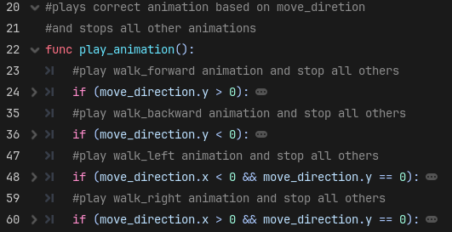

stop_animation(): Stops all currently playing animations. Is used when the player is no longer moving the character.
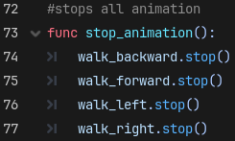
_physics_process(): This function is what Godot uses to calculate physics changes. This function is automatically executed by Godot every frame (at 60 frames per second). The function is constantly resetting move_direction to (0,0) and detected whether the player is pressing a movement button. The movement buttons are assign as a global variable W = “Up”, S = “Down”, D = “Right”, and A = “Left”. This function executes move_and_slide() which is a default function for Godot. The move_and_slide() function allows objects with physical presence to interact. I.E. Character runs into a wall or tree, or the bed.
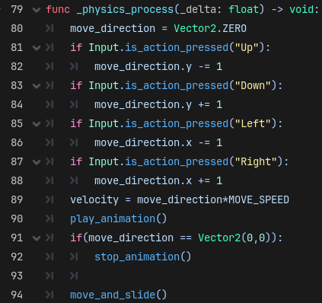

ASL Functions (Quiz/Learning)
The following functions are core components of the game that are used to pull asl signs from 3 different databases of varying difficulty to display ASL Learning and ASL Quizzes. The player learns new signs, then tests their knowledge via ASL Quizzes.

Resource Classes: Both ASLSign and ASLDataBase are resource classes. ASLSign stores a meaning(String), an image(Testured2D), and is_unlocked a Boolean telling the game whether the player has seen this sign before. ASLDataBase contains all_questions a variable that holds an Array of ASLSign’s and a Boolean that tells whether all ASLSigns in the ASLDataBase have been learned. ASLDataBase contains one function: is_learned_test(), which cycles through all ASLSigns contained in all_questions to see if all of them have been unlocked by the player.
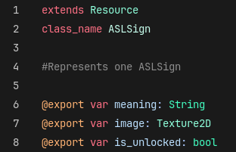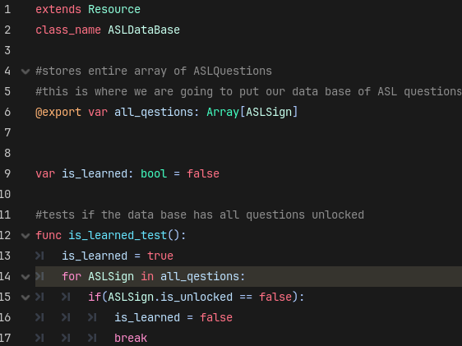

ASLLearning: this class contains one function that is used to get one ASLSign that has not been unlocked from the Array of ASLSigns (ASLDataBase.all_questions). Once a sign is found it marks it as unlocked and returns.
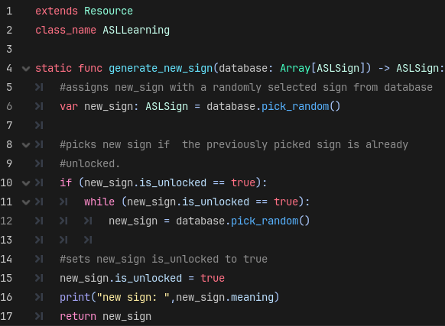
CreateASLLearning: This class contains one function and variable. The variable is used to tell the function how large the array of ASLSign’s should be. The function calls ASLLearning that many times and adds the ASLSign generated from ASLLearning to the array.
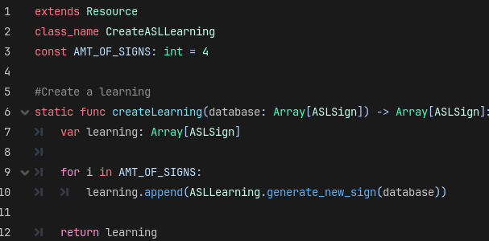
ASL_Learning_UI
This scene is designed to show 4 ASL Signs to the player that they have not seen before. The script contains 2 variables, asl_images which stores references to 4 TextureRect’s contained within the scene and meanings which stores 4 references to Label’s contained within the scene. The start_learning function is given an array of ASLSigns and sets the one of the references in asl_images and meaings to the image and meaning of the ASLSign from the array. This scene contains a button that when pressed uses SignalHub to emit a signal called learning_finished, that prompts game_manager to hide this UI.
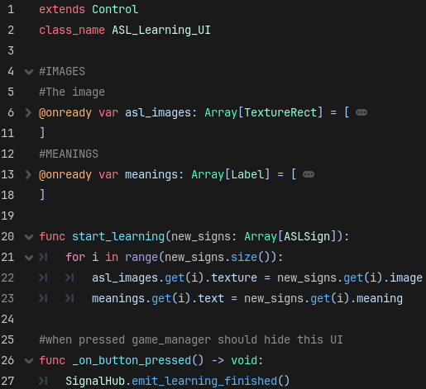

ASLQuestion: This class uses generate_question to create an quiz question using ASLSigns from the ASLDataBase given to it. The generate_correct_sign that gets an ASLSign from the data base that the player has unlocked already and stores that in an array questions at index 0. The generate_random function grabs another ASLSign at random from the database, that is not already contained within array of ASLSign’s, question.
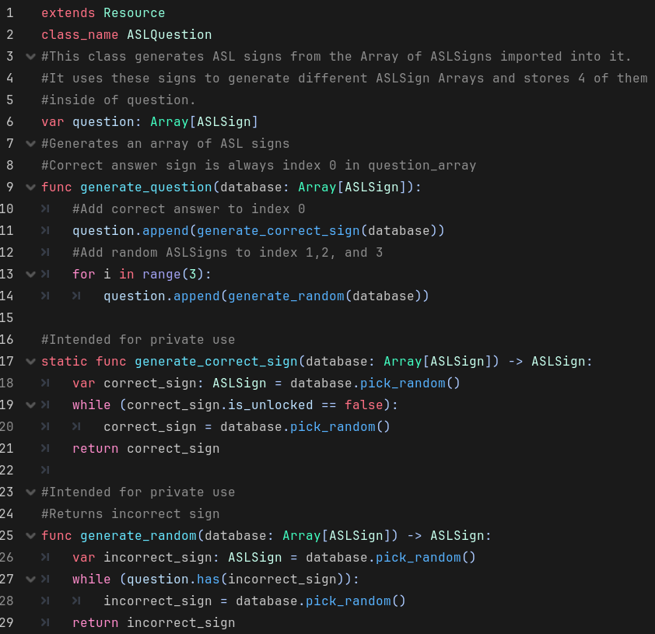

CreateASLQuiz: Instantiates AMT_OF_QUESTIONS (4) ASLQuestion’s, runs generate question for each of them, then stores them in an array, then returns the array of ASLQuestions.
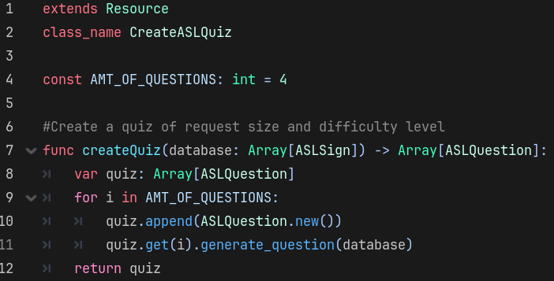

ASL_Quiz_UI
This scene is designed to display multiple quiz questions of different types, both image prompt and meaning prompt, to the player. The player will be able to answer the quiz questions by clicking on one of the answer buttons, as they do the quiz will cycle to the next question.

Variables: Most variables here are used to display a meaning prompt question or an image prompt question. The correct_answer variable is used to set which multiple choice button is correct. quiz_questions is used to store all question for the quiz. It is given an new array each time a quiz is started. quiz_index is the index of the question currently being displayed from the ASLQuestion array.
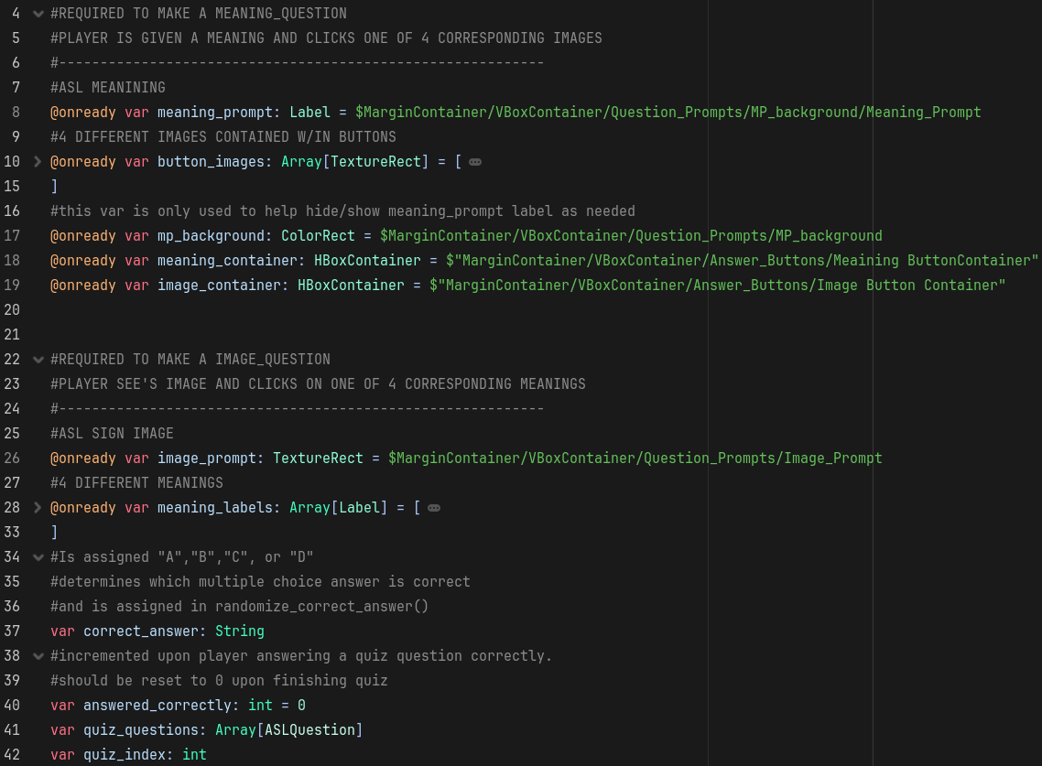
_ready(),randomize_correct_answer(): _ready is executed by Godot when the scene is instantiated. The randomize_correct_answer function is used to randomly determine which multiple choice answer will be the correct one.
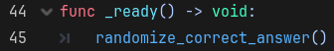
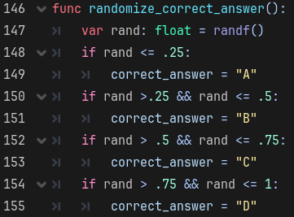

start_quiz(): This function is used to start a new ASLQuiz.
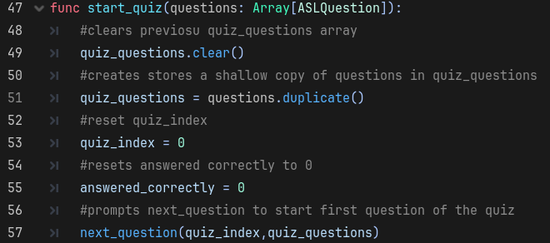
next_question(): This function is used to execute required functions to display the next question of the quiz, when the player answers a question by clicking one of the quiz buttons.
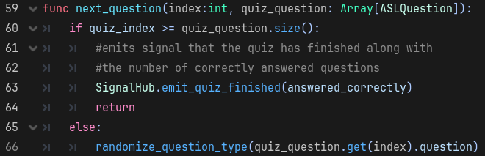

randomize_question_type(): This function is used to determine whether a question is going to be an image prompt question or meaning prompt question.
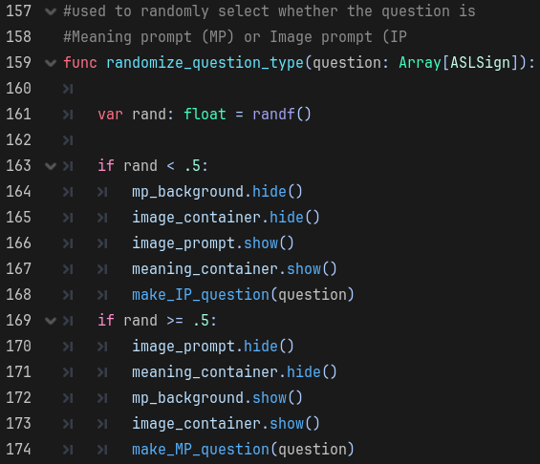

make_IP_question(): This function is used to create a meaning prompt question from the array of ASLSign’s it is given. This function pulls an image from the correct answer (at index 0) and assigns the meanings of all of the rest of the ASLSign’s to the labels in the scene according to whether correct_answer is A,B,C, or D.
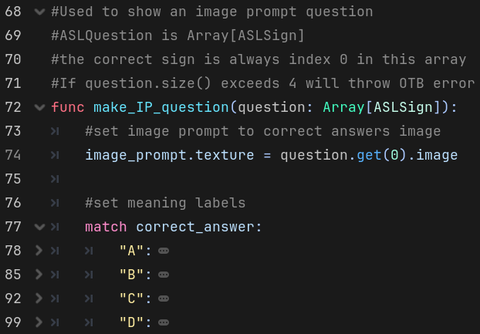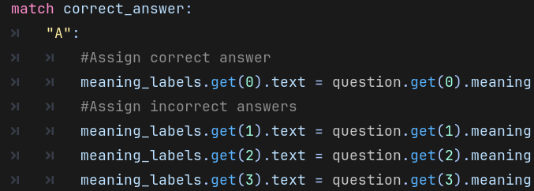

make_MP_question(): This function is used to create an image prompt question from the array of ASLSign’s it is given. This function pulls a meaning from the correct answer (at index 0) and assigns the images of all of the rest of the ASLSign’s to the labels in the scene according to whether correct_answer is A,B,C, or D.
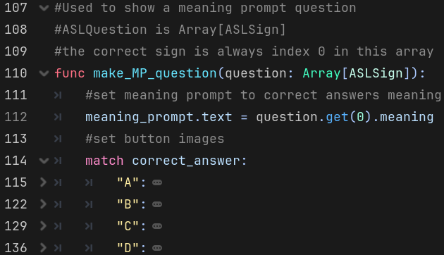
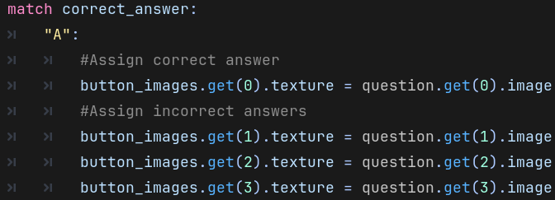

Buttons: The following functions represent buttons in the scene that are shown or hidden according to whether the question is an image prompt or meaning prompt. When the player clicks any button to answer, answer_picked is called.
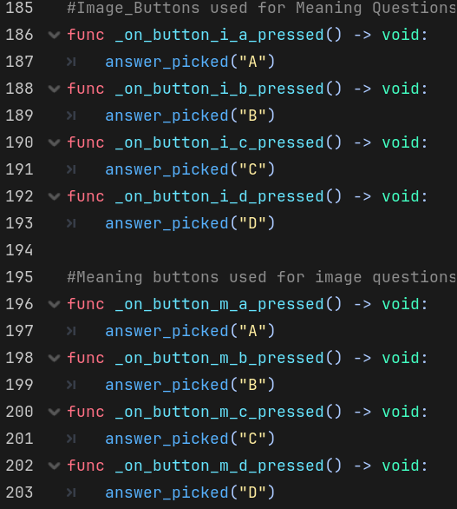

answer_picked(): This function is used to call next_question and determine whether the player picked correctly by comparing the button they pressed to correct_answer and incrementing answered_correctly. It also randomizes the answer to the next question by calling randomize_correct_answer.
